Keep the Faith

Duty…Dignity…Dedication
MEMBERS AND PROSPECTIVE MEMBERS YOUR SHOP STEWARD IN THIS AREA IS:

NAME OF STEWARD:

WORK PHONE NUMBER:

WORK SITE:

AREAS REPRESENTED:

SAMPLE CHAPTER MEETING FLYER

Date: Time:
Place: Dining Facility

Lunch will be: PIZZA

AGENDA / ITEMS OF DISCUSSION:
- Washington Trip
- Change of Stewards
And More…
It’s important to YOU and your CAREER that you attend

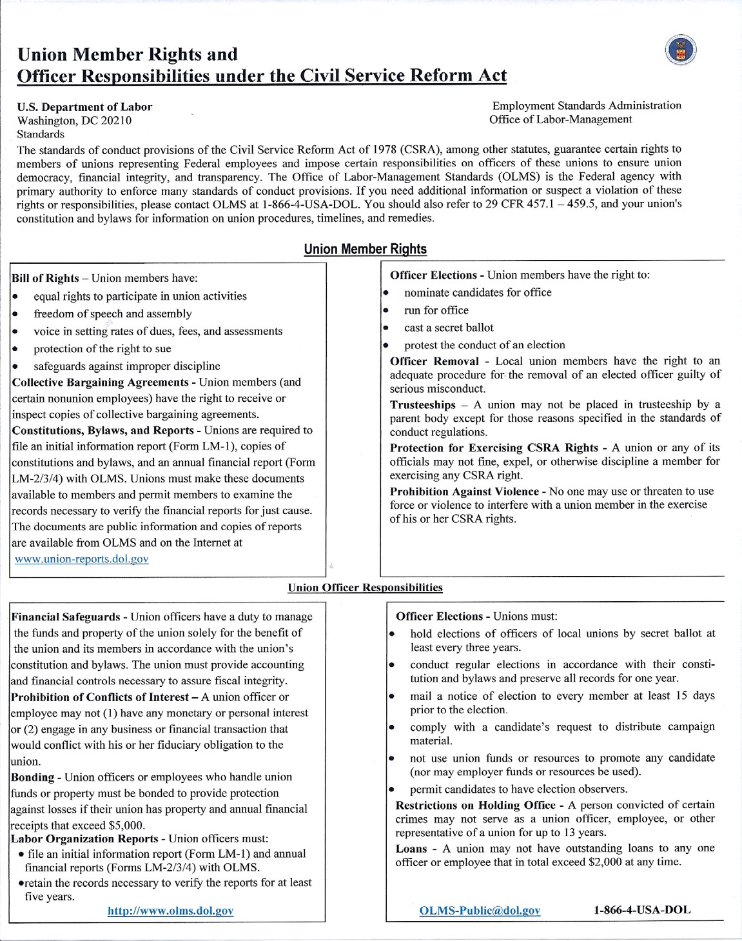

ctober 2017 Page 117 of 1

O

SUPERVISOR’S RECORD OF TECHNICIAN EMPLOYMENT
1. NAME |  |  | 2. DATE OF BIRTH |  |  | 3. SSN |  | 4. SERVICE COMP. DATE
5. HOME ADDRESS & TELEPHONE NUMBER |  |  |  | 6. EMERGENCY INFORMATION
7. MILITARY DATA (UNIT, MOS / AFSC & TITLE, SECURITY CLEARANCE, COMPATIBILITY, ETC.)
8. TECHNICIAN RATINGS OF RECORD
9. POSITION & PERSONNEL DATA (POST INFORMATION FROM SF 50 – DO NOT RETAIN COPIES OF SF 50)
EFFECTIVE DATE | NATURE OF ACTION | POSITION TITLE AND NUMBER |  |  | PAY PLAN & OCC CODE |  | GRADE & STEP | SALARY | ORG / LOCATION

NGB FORM 904-1 (Replaces NGB Form 904-1, dated 1 Sep 88, which is obsolete) Pencil entries PAGE 1 OF

1 DEC 91

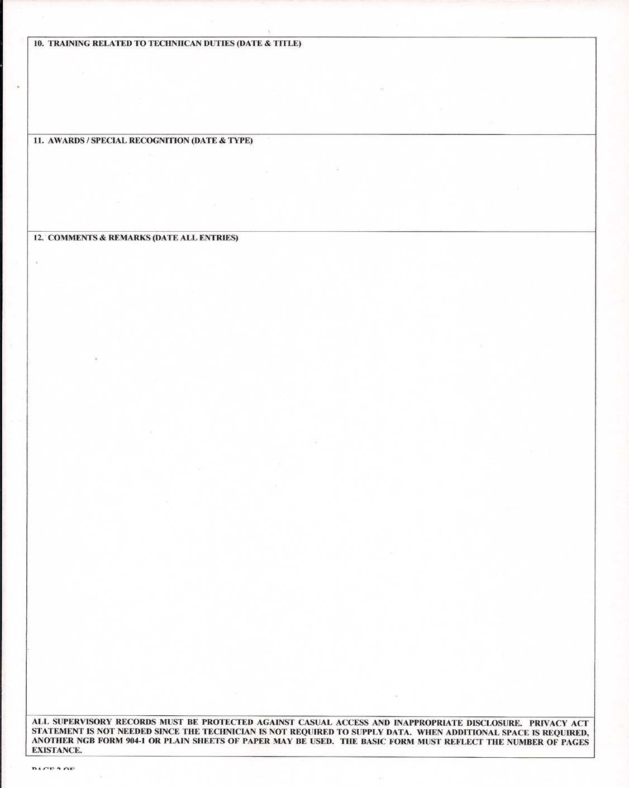

ober 2017 Page 119 of

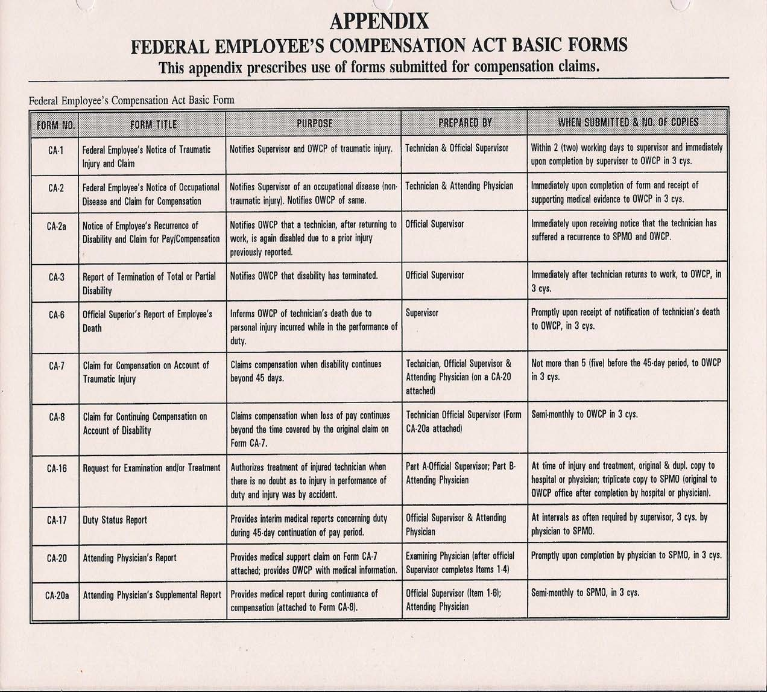

I, , hereby authorize the following listed Labor Organization Representative(s) of the Association of Civilian Technicians, to exercise on my behalf, rights established by law, allowing access to information, including any state law, the Federal Freedom of Information Act, and the Federal Privacy Act. I also authorize all state, federal or other government employees or officials [and all hospitals, doctors, and medical personnel**] to deliver records concerning me to any of the ACT officials indicated or other representative and to discuss freely with any ACT Official any matter or information pertaining to me.

I declare under penalty of perjury that the foregoing is true and correct.

Executed on Signature
(Date)

** include bracketed words if medical records are relevant.

Received By:
Date:

CERTIFIED MAIL No.

SAMPLE LETTER #1

Date:

CWO Paul O'Connor
(HRO) - (Commander) - (Superintendent) Union Designation or FMS # Street Address
City or Town, New York

RE: Disciplinary Action - Letter of Reprimand for James H. Hamilton (fictitious)

Dear CWO O'Connor:

In preparation to represent James H. Hamilton in his upcoming administrative hearing relative to the above-captioned matter I am requesting, in accord with 5 U.S.C. 7114 (b)(4), the following data from your office within five (5) workdays from the receipt of this letter. If you cannot provide me with the requested information, please forward this letter to the appropriate official or advise me where it can be obtained:

- James H. Hamilton's entire personnel record.

- The record of tardiness of all other employees under your supervision for the past three years.

- The names of employees within (Your State ) who have been disciplined for tardiness within the past three years, to include the date and description of each discipline; i.e., letters of reprimand, suspensions or terminations.

Sincerely,

JOHN T. UNION
Shop Steward or Chapter Officer

cc: Field Rep Chapter President

Received By:

Date:

CERTIFIED MAIL No.

SAMPLE LETTER #2

Date:

NAME/RANK (HRO) (COMMANDER) (SUPERINTENDENT) STREET ADDRESS CITY, TOWN, STATE, ETC

RE: Disciplinary Action-letter of Reprimand for John Q. Public Dear Colonel ???,
In preparation to represent John Q. Public, in his upcoming administrative hearing relative to the above captioned matter, I am requesting the following information from your office. This information is needed to determine if the letter of reprimand issued to Mr. Public is appropriate in light of his employment history and consistent with discipline of other employees in similar circumstances. If you cannot provide me with the requested information, please forward this letter to the appropriate official or advise me where it can be obtained.

- James Q. Public's entire personnel file. Enclosed is Mr. Public's authorization for you to send me information pertaining to him.

- The record of tardiness of all other employees under your supervision for the past three years, with personal identifiers deleted, but with indication of whether the employee was ever disciplined for tardiness, and if so when, for what tardiness, and what discipline was imposed.

- All records concerning discipline of employees within (your state) who have been disciplined for tardiness within the past three years, to include the date and description of each discipline, i.e., letters of reprimand, suspensions or terminations.

I request that personal identifiers be deleted from these records but that the records be coded so that all records pertaining to a particular employee and each instance of discipline of that employee, can be identified (for example, "Employee #l-Discipline Imposed on [Date])".

Sincerely,

John T. Union (your position & title)

cc: Field Rep Chapter President

Received By:

Date:

CERTIFIED MAIL No.

SAMPLE LETTER #3
FOR APPROPRIATE BARGAINING

Date:

RANK/NAME TITLE
Combined Support Maintenance Shop or FMS (STATE) National Guard
Street Address
City, Town, State, Zip Dear (rank/name)
It has come to our attention that a change of policy is being considered with regard to . The changes that we are led to believe will occur, (may or will) impact upon the working conditions of employees within the bargaining unit represented by our organization.

As I am sure you are aware, the Statute provides that the Association must be provided with reasonable advance notice and given the opportunity to seek negotiations regarding any changes to working conditions of the employees within our recognized bargaining unit.

This letter will therefore serve as our formal request to you that we wish to negotiate this matter.

Under the provisions of 5 U.S.C 7114(b) (4),the Labor Organization hereby requests that it be provided with any and all data relating to the and that the data be forwarded to us within five (5) workdays following your receipt of this letter. The Labor Organization needs this information in order to consider and to prepare proposals addressing whether the change should occur and, if so, its impact.

After we receive and have had an opportunity to review all of the materials, we shall arrange to meet and discuss with you proposals concerning the above matter.

Sincerely,

John T. Union (your position & title)

cc: Field Rep Chapter President

Received By:

Date:

CERTIFIED MAIL No.

SAMPLE LETTER #4

FOR APPROPRIATE BARGAINING MOST COMMONLY USED REQUEST

Date:

Colonel CWO (name) Superintendent or Supervisor
Combined Support Maintenance Shop or FMS New York National Guard (Street Address)
City town and State Zip Code

Dear Colonel/CWO

It has come to our attention that a change of policy is being considered with regard to? The changes that we are led to believe will occur, and will impact upon the working conditions of employees within the bargaining unit. As I am sure you know the Statute provides that the Association must be provided with reasonable advance notice and opportunity to seek negotiations regarding any changes to working conditions of employees within the recognized bargaining unit.

This letter will therefore serve as our formal request to you that we wish to negotiate this matter.

Under the provisions of 5 U.S.C. 7l14(b)(4), the Association hereby requests that we be provided with any and all data relating to the and that the data be forwarded to us within five (5) workdays following your receipt of this letter.

After we receive and have had an opportunity to review all of the materials, we shall arrange to meet and discuss with you (or forward proposals to you) concerning the above matter.

Sincerely, (sign name here)
JOHN T. UNION Shop Steward

cc: Field Rep Chapter President

Received By:

Date:

CERTIFIED MAIL No.

SAMPLE LETTER #5

FOR APPROPRIATE BARGAINING ON REORGANIZATION / RIF

Date:

RANK, NAME
TITLE (AIR COMMANDER) YOUR UNIT
STATE, AIR OR ARMYNATIONALGUARD ADDRESS
CITY, TOWN AND STATE

Dear _

On behalf of the Chapter, Association of Civilian Technicians, the undersigned respectfully requests that you provide us with copies of the Department of the Air Force or Department of the Army; (of your state) National Guard letters, bulletins, the current and proposed manning documents, etc. pertinent to the upcoming (RIF/REORG).We request that this data be provided to the Labor Organization within five (5) workdays of your receipt of this request.

The Labor Organization needs this data to monitor the RIF’s implementation with respect to compliance with RIF laws and regulations (and thereby to determine if grievances or other challenges to the RIF should be presented), and to prepare proposals addressing the purposed RIF.

This letter also serves as our formal request to commence negotiations with you or your representative from the office of the Adjutant General, concerning the procedures to be followed in carrying out the forthcoming reduction in force.

We propose that no further reduction in force or other personnel changes be implemented until we have had an opportunity to review the materials requested above and until we meet with you and complete bargaining and have concluded a signed agreement pertaining to this important issue.

Sincerely, (sign name here)
JOHN T. UNION Shop Steward

cc: Field Rep Chapter President

Received By:

CERTIFIED MAIL No
Date:

.

Date:

SAMPLE LETTER #6

FOR APPROPRIATE BARGAINING WORK OR SHIFT CHANGES

John Pain (Job Title)
(Org. Unit Name)
(Your State) National Guard (Street Address) Town, City and State w/zip

Dear Major,

As you know, I wrote to you on (Date) , notifying you of the Association's intent to negotiate over management's decision to establish a second (night) shift on or about (Date) .
Pending discussions of this matter, the following initial proposals are herewith submitted:
- The employer will inform the union of the number, types and qualifications of employees that management requires to fulfill the mission assigned to the night shift.

- It is agreed that volunteers for the night shift assignment will be solicited first from among employees having the required qualifications determined by management.

- If an insufficient number of volunteers cannot be found, assignment to the night shift will be made on the basis of seniority. A seniority list of all qualified bargaining unit employees will be prepared by management and a copy of the list provided to the union prior to its use. Assignment to the night shift will then be made from the seniority list with the least senior employees being assigned first. The employer will ensure that the seniority list is kept current.

- Employees volunteering or involuntarily assigned to the night shift may have a trial period to assess the impact of the change from day to night shift on commuting time or transportation difficulties.

- After the night shift personnel have identified and assigned, the employer will prepare and maintain a night shift seniority list, a current copy of which will always be provided to the union.

- For circumstances covering situations not addressed in other proposals herein, the Employer and Association will enter into discussions to establish criteria for determining whether to grant requests of employee’s assigned (night shift) to switch from day to night shift or from night shift to day shift.

- Vacancies occurring on the regular day shift may be filled by transfer from the night shift if requested by the employee and provided the employee is qualified for the position. If more than one employee desires a shift change, then seniority status will determine eligible to change shifts.

Major (Name) Page 2

- Night shift employees will maintain the current Alternate Work Schedule plan unless an involuntarily assigned employee can show an adverse impact on family members resulting from unattended children, inability to care for a sick family member, etc.

- If days off for night shift personnel on AWS will be staggered, the choice of days off will be determined on the basis of seniority.

- The Association will be given a minimum of fourteen (14) days prior notice of any intent to continue the night shift beyond the currently projected expiration date.

- All mutually agreed upon procedures resulting from these discussions will be reduced to a written memorandum of agreement and signed and dated by the responsible union and management officials. Reasonable advance notification and opportunity for negotiations will be provided to the Association relating to any changes to the procedures outlined in the memorandum of agreement.

- The Association proposes that the effective start date of the night shift be held in abeyance until the conclusion of bargaining over management's decision to establish the night shift.

Upon the employer's receipt of these proposals, the Association is prepared to immediately meet and discuss them.

The Association reserves the right to submit further proposals resulting from the discussions of the above or related matters with the employer.

Sincerely, (sign name here)
JOHN T. UNION Shop Steward

cc: Field Rep Chapter President

Received By:

Date:

CERTIFIED MAIL No.

SAMPLE LETTER #7

FOR APPROPRIATE BARGAINING REORGANIZATION OR AIRCRAFT CONVERSION

Date:

Colonel (Name)
(Your unit Designation) (State) National Guard Address City town and State

Dear Colonel

This letter follows my earlier letter to you, dated , in which I requested certain documents from you in connection with the proposed (reorganization; conversion or reduction-in force) conversion to type aircraft.

Upon review of some of the material(s) we received from you, and following discussions held recently with certain members of your staff, the Association has determined that certain matters need to be addressed immediately. Therefore, we are herewith submitting the following proposals until we have fully completed our review of the documents requested earlier:

  - The Association will be consulted at least five (5) work days prior to any formal meetings by management officials with bargaining unit employees relative to the (conversion, reorganization or RIF).

  - The Chapter (or Council) will be informed and given an opportunity to negotiate the procedures involved relative to the procedures to be followed in transferring employees from one functional work area to another.

  - Employees transferred to another work area will have priority placement rights to return to their original work area(s) when vacant positions become available for which they are qualified.

  - Procedures will be established addressing transferred employees who are unable to achieve appropriate skill levels in their newly assigned positions, i.e. providing them with the ability to retreat to their former positions or one in a previously held occupational family group.

  - Procedures which will be followed by the Employer when hardship situations arise involving employees attending, or scheduled to attend training schools at locations other than (name your facility or base).

  - The Employer and the Association will immediately begin to collect data and other necessary findings relative to determining the possibility of receiving approval for early-out retirements for eligible bargaining unit employees.

  - Offering all available positions within the bargaining unit to bargaining unit employees first. No non- bargaining unit employees will compete with bargaining unit employees for bargaining unit positions.

In closing, the union wishes to advise the Employer that we reserve the right to present further bargaining proposals to you or your designated representative(s) following our receipt and review of all available documents we requested relevant to the conversion.

Sincerely,
(sign name here)

JOHN T. UNION Shop Steward

cc: Field Rep Chapter President

Received By:
Date:

CERTIFIED MAIL No.

SAMPLE LETTER #8

FREEDOM OF INFORMATION REQUEST

Agency Head or FOIA Officer Name of Agency
Address of Agency City, State, Zip Code
RE: Freedom of Information Request Dear ???,
Under the provisions of the Freedom of Information Act, 5 USC § 552 I request, for each selective retention board held in 1990, 1991, 1992, 1993, 1994 and 1995, records showing

    - the date the board was held,
    - the number of Army National Guardsmen considered by the board,
    - the number of Army National Guardsmen considered by the board who are or were technicians, "
    - the number of Army National Guardsmen separated by the board,
    - the number of Army National Guardsmen separated by the board who were technicians,
    - the number of Air National Guardsmen considered by the board,
    - the number of Air National Guardsmen considered by the board who are or were technicians,
    - the number of Air National Guardsmen separated by the board,
    - the number of Air National Guardsmen separated by the board who were technicians,
    - any other statistical or narrative information prepared for purposes of reporting the board’s actions.

For any year in which no board was held, I request records indicating the decision not to hold a board that year or the reasons for that decision.

I request a waiver of all fees for this request. Disclosure of this information to me is needed to assess the nature and scope of any adverse impact on civilian technicians as a direct result of actions taken by the retention board.

Thank you for your consideration in this matter.

Sincerely, (sign name here)
JOHN T. UNION Shop Steward

cc: Field Rep Chapter President
Received By: CERTIFIED MAIL No.

Date:

SAMPLE # 9

MODEL AGREEMENT FOR A LABOR-MANAGEMENT COUNCIL

Introduction
Below is a model collective bargaining agreement to establish a labor-management council. The purpose of the agreement is to supplement collective bargaining by creating a process for resolving—by agreement or unilateral agency action—conditions of employment that are not within the mandatory scope of bargaining and not covered by or contained in a collective bargaining agreement. These conditions of employment include, primarily, matters that are non-negotiable 5 U.S.C. § 7106(a) management rights and matters, such as § 7106(b) (1) subjects, that are negotiable only at the election of the agency, and that the agency has elected not to negotiate.
The outcome of council discussions may be an agreement or a unilateral agency determination; but, even if the outcome is an agreement, it is not a collective bargaining agreement. This is because, as stated above, it concerns matters that the agency cannot be required to negotiate and has not agreed to negotiate. The outcome, however—whether agreed or unilateral—may be an enforceable agency rule or regulation, if the agency so agrees.
In sum, although the model agreement is, itself, a collective bargaining agreement, its purpose is to supplement collective bargaining by establishing a process for resolving matters over which the agency is not required to bargain.

Agreement

This is an agreement under 5 U.S.C. 7114(b) (5) between the United States Department of Defense, National Guard Bureau, [State] National Guard (hereafter “agency”) and the [Name of] Chapter of the Association of Civilian Technicians, Inc. (hereafter “union”). By the signatures of their representatives below the parties agree as follows.

Establishment of Labor-Management Council
- The parties hereby establish at the bargaining unit level a labor-management council.

Council Membership
- Each union officer or steward is a member of and a union representative on the council.
- The agency will designate as members of and agency representatives on the council a number of persons equal to the number of union representatives who are council members. The agency promptly will inform the union of its designations.

Additional Representatives
- As to any council matter, the union or the agency may designate any person (for example, an agency official or employee who works at the national, state, or local level; an attorney; or a national union officer or field representative) as an additional representative regarding the matter.

Authority of Representatives
- Agency representatives will be duly authorized to determine and execute an agreement concerning any condition of employment that is neither (a) a matter within the mandatory scope of bargaining nor (b) a permissive subject of bargaining covered by or contained in a collective bargaining agreement—except that, in lieu of being authorized to determine or execute an agreement concerning these conditions of employment,

agency representatives may be authorized to recommend determinations or agreements to officials having authority to make or to execute them.
- Union representatives will be duly authorized to execute an agreement concerning any condition of employment described in paragraph 5.

Pre-Decisional Involvement (PDI)
- The union representatives will be afforded, to the fullest extent practicable, pre-decisional involvement (PDI) concerning all conditions of employment described in paragraph 5. PDI means, as stated below, discussion, other communication, provision of information, and investigation concerning conditions of employment, before they are determined by the agency.
- PDI concerning a condition of employment described in paragraph 5 will begin before the agency proposes a change in policy or practice. The agency expeditiously will inform union representatives and begin their pre-decisional involvement when a possible problem or idea for potential improvement concerning such a condition of employment is identified, or when a matter concerning such a condition of employment is identified as a priority for investigation or consideration of possible change.
- PDI also will begin when a problem, idea for improvement, or matter for investigation or consideration, concerning a condition of employment described in paragraph 5, is identified by union representatives.

Good Faith Attempt to Resolve Issues
- Through council discussions or other communication with union representatives, the agency will make a good-faith attempt to resolve issues concerning changes—proposed by either the agency or union representatives—in conditions of employment described in paragraph 5.

Provision of Information and Investigation
- When PDI begins, the agency, without waiting for a request, expeditiously will provide council union representatives adequate information on the matter, to the extent its provision is not prohibited by law or agency internal security practice. If the union requests additional information, the agency expeditiously will provide it or state in writing the facts and reasons why it is not needed or its provision is prohibited by law or agency internal security practice.
- If adequate information is not available, PDI will include reasonable investigation not prohibited by law or agency internal security practice.

Meetings

- The council will meet at least quarterly. In addition, PDI will include other council meetings reasonably necessary to timely discuss—regarding conditions of employment described in paragraph 5— problems, issues, proposed solutions, ideas for improvement, needed information or investigation, or investigative plans. Both agency and union representatives have the right to place matters on the agenda for a meeting. For each meeting, the agency will prepare minutes stating the subjects and issues discussed and the views and recommendations stated.
- Meetings will occur during normal business hours. In addition to agency and union representatives, other employees who have expertise or have demonstrated an interest in a matter to be discussed will, to the fullest extent practicable, be authorized to attend.

Official Time and Expenses

- The agency will authorize official time under 5 U.S.C. § 7131 and payment of reasonable expenses for all union council members to prepare for, travel to, attend, and travel from meetings of the council.
- Time to prepare for meetings includes reasonable time to identify problems, request and study information, investigate, prepare written statements or proposals, and consult with employees and other union representatives.
- Travel expenses include transportation, meals, and lodging. Payment will be in accordance with the applicable agency regulation.
- Expenses to prepare for meetings include document reproduction and delivery, and travel expenses for investigation and consultation with employees and other union representatives.
- Employees authorized to attend a council meeting due to their expertise or demonstrated interest in a matter to be discussed will be granted § 7131 official time and payment of their reasonable expenses for travel to and from and attendance at the meeting.

Agreement or Agency Unilateral Determination

- Conditions of employment described in paragraph 5 will be determined by agreement or unilateral agency action. The determination will be stated in writing. Upon union request, the determination (whether agreed or unilateral) will be an agency rule or regulation enforceable under the negotiated grievance procedure, unless the agency states in writing facts and reasons why the determination should not be enforceable.
- If the agency by unilateral action determines a condition of employment described in paragraph 5 and the determination is inconsistent with a union view or recommendation presented during PDI, the agency will state in writing the reasons for the determination and the facts on which the reasons are based, including reasons and supporting facts that directly address the union view or recommendation and explain why it was not adopted.

For the [State] National Guard

Date

For the [Name of] Chapter, Association of Civilian Technicians, Inc.

Union Representative Date

SAMPLE #10: Contract Language for Integration

This is a 5 U.S.C. § 7114 collective bargaining agreement between the _ Chapter of the Association of Civilian Technicians (hereafter “ACT” or “union”) and the United States Department of Defense, its component, the Department of the Air Force or Army, including the National Guard (hereafter “agency”). The union and the agency agree as follows.

- This is an initial agreement concerning some matters pertaining to the implementation of the agency’s Integration Plan for integrating the Air or Army. The parties agree to continue to negotiate matters pertaining to the integration in a good faith effort to reach additional agreements and agree that any impasse over a negotiable matter will be presented to the Federal Service Impasses Panel for binding resolution under 5 U.S.C. § 7119.

- After receipt of guidance from the National Guard Bureau or the Department of Defense Civilian Personnel Management Service, the agency will decide whether to elect to negotiate matters within the scope of 5 U.S.C. § 7106(b)(1) and will inform the union of its decision.

- Implementation of the integration involving any change in a condition of employment will be held in abeyance pending completion of appropriate collective bargaining, including resolution of any impasse by the Federal Service Impasses Panel (FSIP), unless implementation is consistent with the necessary functioning of the agency or necessary to correct an unlawful practice.

- If the agency contends that any implementation of the integration changing a condition of employment before completion of appropriate collective bargaining is consistent with the necessary functioning of the agency, the agency will provide to the union a written statement of each change made, or to be made, based on that contention, and with respect to each change (a) each agency function that is necessary and that cannot be performed without the change, (b) each fact and reason on which the agency bases its contention that the function is necessary, and (c) each fact and reason on which the agency bases its contention that the function cannot be performed without the change.

- If the agency contends that any implementation of the integration changing a condition of employment before completion of appropriate collective bargaining, including FSIP resolution of any impasse, is necessary to correct an unlawful practice, the agency will provide to the union a written statement of each change made, or to be made, based on that contention, and with respect to each change (a) each unlawful practice that must be corrected (b) each fact and reason on which the agency bases its contention that the practice is unlawful, and (c) each fact and reason on which the agency bases its contention that the change is necessary to correct the unlawful practice.

- In addition to any right to information that the union may have under 5 U.S.C. § 7114, the agency will provide to the union, or inform the union where on the internet it can obtain without charge, each document prepared or considered by the agency in establishing a plan for, or a policy or practice concerning, the integration—except that the agency need not provide a part of a document if disclosure of that part to the union is prohibited by law.

- The agency will inform the union in writing of each proposed change in a condition of employment that is related to the integration and an exercise of a 5 U.S.C. § 7106(a) management right—stating which right is involved and identifying the change with reasonable specificity. Thereafter, the agency will afford the union a

reasonable opportunity to negotiate § 7106(b)(2) procedures that management officials will observe in exercising the right. If the union discovers such a proposed or implemented change of which it was not informed with reasonable specificity in writing, the union within a reasonable time thereafter may propose, and the agency will afford the union reasonable opportunity to negotiate, (b)(2) procedures concerning the change. Implementation of the change, if already commenced, will be suspended pending completion of bargaining, except as provided in paragraph 3.

- With respect to a proposed or implemented change in a condition of employment that is related to the integration and an exercise of a 5 U.S.C. § 7106(a) management right, the agency may inform the union in writing, with reasonable specificity, of a possible adverse effect on employees. If the agency does this, it shall then afford the union a reasonable opportunity to negotiate § 7106(b)(3) appropriate arrangements for employees adversely affected by the change. If with respect to such a proposed or implemented change the union discovers an adverse effect—and the union was not previously informed by the agency in writing, with reasonable specificity, of its possibility—the union within a reasonable time after its discovery may propose, and the agency will afford the union reasonable opportunity to negotiate, (b)(3) appropriate arrangements concerning the effect. Implementation of the change, if already commenced, will be suspended pending completion of bargaining, except as provided in paragraph 3.

- The union at any time may request that the agency issue a written statement of policy or practice regarding any matter that is within the scope of 5 U.S.C. § 7106 management rights, that is not within the scope of collective bargaining, and that is related to the integration. A union request may include the text of a proposed statement. Within a reasonable time, the agency will provide to the union a proposed written statement regarding the matter. The agency will afford the union reasonable time to submit views or recommendations regarding the proposed statement; consider any views or recommendations submitted by the union; issue a written statement of policy or practice regarding the matter, within a reasonable time; and, to the extent the statement does not implement a union view or recommendation, state the facts and reasons on which the agency based its decision not to implement the union view or recommendation.

- Upon request of the union, the agency within a reasonable time will meet with the union during normal duty hours to discuss matters related to the integration. The agency will grant two union representatives official time to prepare for and attend the meeting. A request for, or discussion at, a meeting does not waive the right to collective bargaining concerning any matter.

- The union at any time may propose that the agency, alone or jointly with the union, conduct a study of any aspect of the integration. Upon request, the agency will afford the union reasonable opportunity to negotiate proposals for such studies.

- Before implementation of the integration, and proportionate to any increase in number of users resulting from the integration, the agency will increase the size of the break areas and rest rooms that are used by employees. The agency will ensure that the integration does not reduce the availability of tools, parking spaces, benches, lockers, safety equipment, or other equipment or facilities used by employees.

- Before implementation of the integration, the agency will provide to the union a written statement of the agency’s policy and practice concerning training of active duty supervisors and managers regarding the collective bargaining agreement and the statutory and regulatory employment and labor law rights of employees to whom they may be authorized to give operational direction.

- Before implementation of the integration, the agency will provide to the union a written statement of the practices and means it will use to implement the following policies stated in the Integration Plan:

. . . . Workload will be equitably distributed among and personnel. For work centers operating on both shifts, the personnel assigned to each shift should be equitably balanced between and personnel. Coverage for requirements outside of primary work hours (e.g. transient aircraft handling, maintenance recovery team, CORONET activity, NETTF Air Bridge, AMC activity, repair or launch/recovery of unit assigned aircraft) should also be equitably balanced between and personnel. When devising work schedules, supervisors will ensure appropriate skill set and qualification level, and adjust manning accordingly.

. . . . The workload will be equitably distributed among and
personnel. Coverage for

requirements outside of the normal work schedule will be equitably balanced between and
personnel.

. . . The workload will be equitably distributed among and
personnel. Coverage for

requirements outside of the normal work schedule will be equitably balanced between and
personnel.

. . . . The workload will be equitably distributed among and personnel. Coverage for requirements outside of the normal work schedule will be equitably balanced between and
personnel.

Agency Representative/Date

Union Representative/Date

SAMPLE #11: Integration Memorandum of Agreement

This is a 5 U.S.C. § 7103(a)(9) rule or regulation affecting conditions of employment issued by the
National Guard with the agreement of the Chapter of the Association of Civilian Technicians (ACT or “union”). This is not a 5 U.S.C. § 7114 collective bargaining agreement.

- This is an initial agreement concerning some matters pertaining to the implementation of the Integration Plan for integrating the and the . Nothing in this agreement waives or modifies the union’s right to collective bargaining over the integration.

- The retains the legal right to change, at any time, a policy stated in this Memorandum of Agreement, subject to the following two conditions: (1) if the proposed change is a matter that is within the scope of collective bargaining, the 5 U.S.C. § 7103(a)(3) agency of which the is a part must notify the union of the proposed change, negotiate with the union over whether the change will occur, and preserve the status quo pending completion of the negotiations, including resolution of any impasse by the Federal Service Impasses Panel; (2) if the proposed change is a matter that is not within the scope of collective bargaining, the agency must notify the union of the proposed change, negotiate with the union over the impact and implementation of the proposed change, and preserve the status quo pending completion of the negotiations, including resolution of any impasse by the Federal Service Impasses Panel. If the union agrees with a proposed policy change, then this Memorandum of Agreement will be changed by mutual agreement of the parties. If after complying with the appropriate bargaining obligation the agency changes a policy without the union’s agreement, the new policy supersedes this Memorandum of Agreement with respect to that policy. In either case, the new policy, like this Memorandum of Agreement, will be a local agency rule or regulation.

- The parties agree to continue to negotiate, consult, and work collaboratively and cooperatively in an effort to reach agreement, or in the absence of agreement, clear understanding, of how the integration will occur. These efforts will include working together to prepare a written summary concerning facilities and equipment that affect conditions of employment—including but not limited to rest rooms, break areas, tools, parking spaces, benches, lockers and safety equipment available to employees before and after integration, and developing solutions to mitigate adverse impacts. The preparation or content of the summary or any developing of solutions to mitigate adverse impacts is not a waiver of the union’s right to collective bargaining over any matter. The union reserves the right to negotiate proposals irrespective of whether they are consistent or inconsistent with the summary or any solution prepared or developed under this paragraph.

- The meaning and intent of the term “operational direction” as it is contained in the Integration Plan, include the following. The purpose of the concept of operational direction is to encourage a cooperative and collaborative work environment for members of the and the _; this could include directing the manner and type of work to be done by a member of the other organization. Under no circumstance will members of either organization exercise supervisory authority over members of the other. In this context supervisory authority includes reprimanding, admonishing, writing performance appraisals or performance reports. Operational direction is authority exercised by commanders or supervisors of one component over personnel from another component in order to provide unity of direction for operational matters. Operational direction includes the authority to assign tasks, designate objectives, and provide direction necessary to accomplish the mission; it does not include command or supervisory authority. The Host Wing/CC has operational directive authority over the Active Associate Squadron in order to provide unity of effort for operational matters. Operational direction includes the authority to assign tasks, designate objectives, and provide direction necessary to accomplish the mission. This is not a command authority nor is it to be confused

with the command responsibility to the Active Associate _. The meaning of “operational direction” may be further clarified in the future.

- The will include in the training for supervisors and managers of the who may have operational direction authority over technicians a module on the collective bargaining agreement, this agreement, and the legal and regulatory structure as it applies to National Guard civilian technicians. The will invite union representatives to attend and contribute to this training. The also will provide briefer training concerning these matters to other new comers who are members of the _.

Agency Representative/Date

Union Representative/Date

